LV1
Computer: 192.168.101.1
DSRC_Eth: 192.168.101.10
DSRC_Wave:192.168.100.1

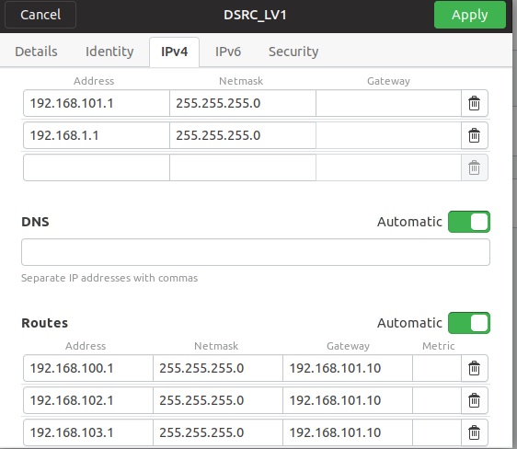

FV1:
Computer: 192.168.102.1
DSRC_Eth: 192.168.102.10
DSRC_Wave:192.168.100.2

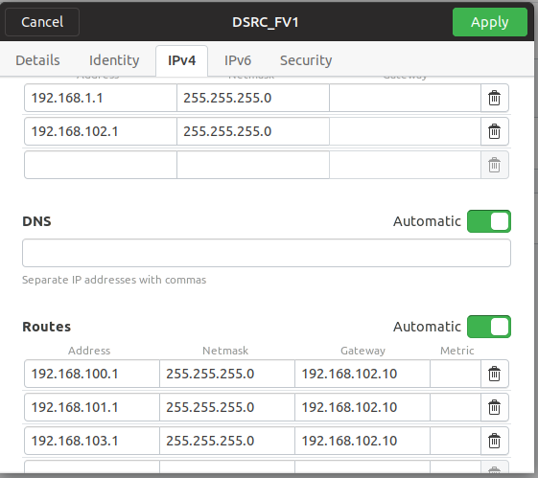

FV2:
Computer 192.168.103.1
DSRC_Eth: 192.168.103.10
DSRC_Wave:192.168.100.3
